Test Case: tc001_SPX_Dev5_Crear_Requisicion_Spot_Tipo_Cobro_CC
Step 1 - Enter username and password and click to button Enter : Credentials Entered
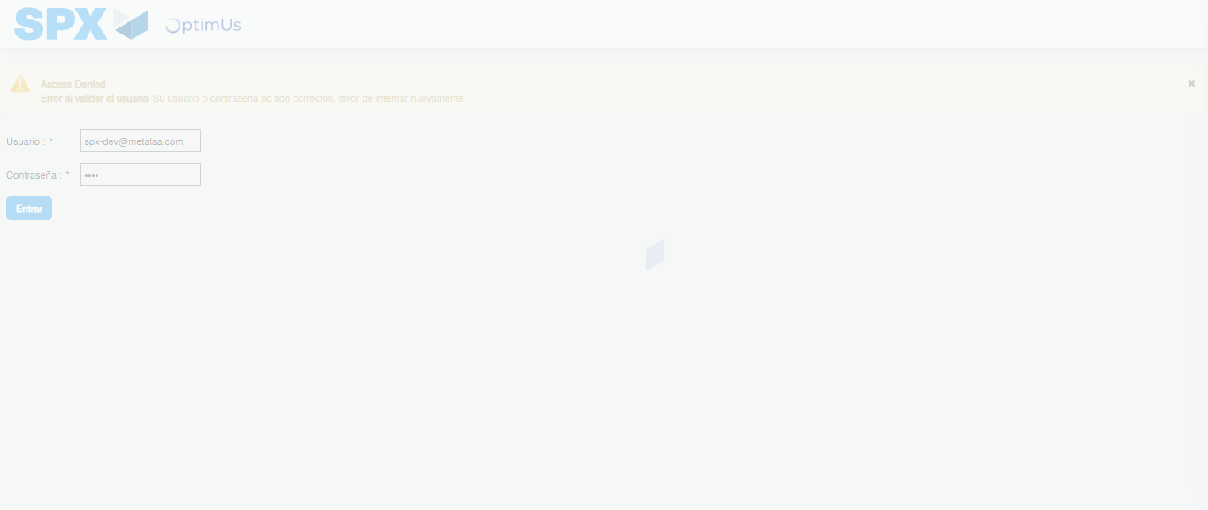Image file-name: QC_Testing-tc001_SPX_Dev5_Crear_Requisicion_Spot_Tipo_Cobro_CC-1788297481946

Step 2 - Select to UEN and Access to Spot Buy Requisitions : UEN Correctly selected and Correct access
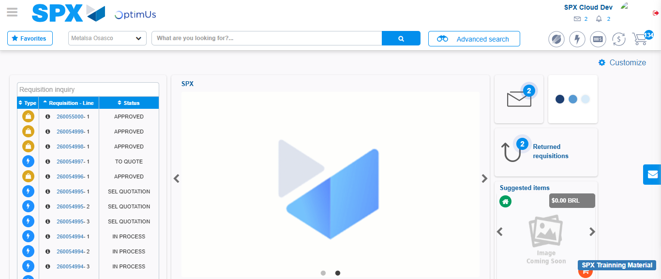Image file-name: QC_Testing-tc001_SPX_Dev5_Crear_Requisicion_Spot_Tipo_Cobro_CC-1788297508564

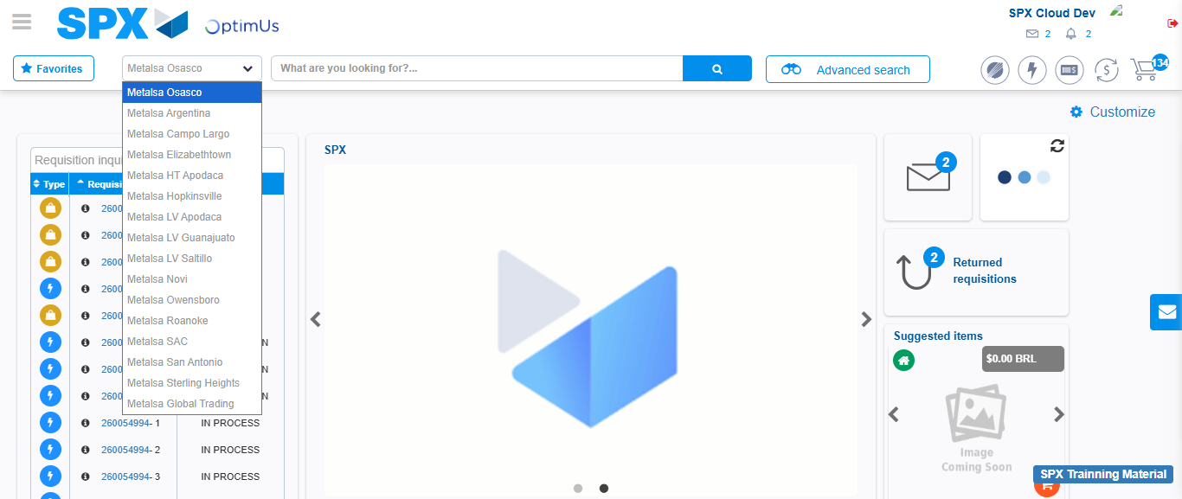Image file-name: QC_Testing-tc001_SPX_Dev5_Crear_Requisicion_Spot_Tipo_Cobro_CC-1788297509287

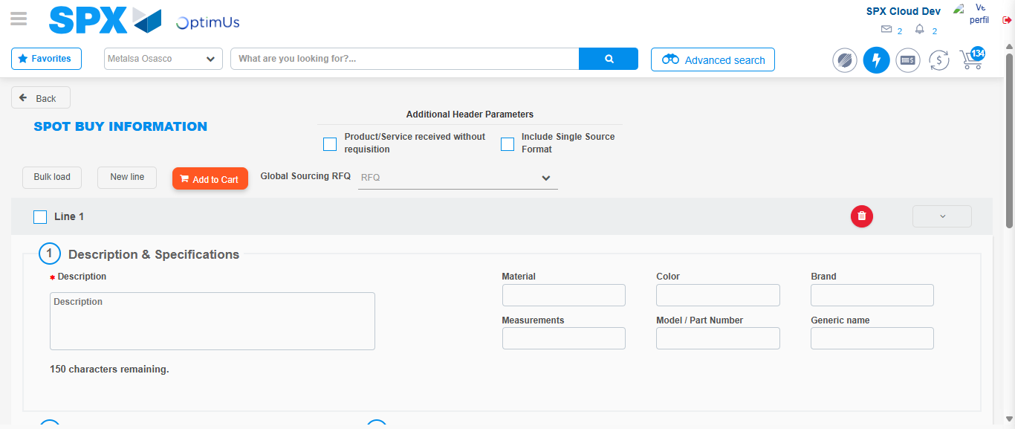Image file-name: QC_Testing-tc001_SPX_Dev5_Crear_Requisicion_Spot_Tipo_Cobro_CC-1788297532605

Step 3 - Data Capture Spot Buy Requisition : Data captured correctly
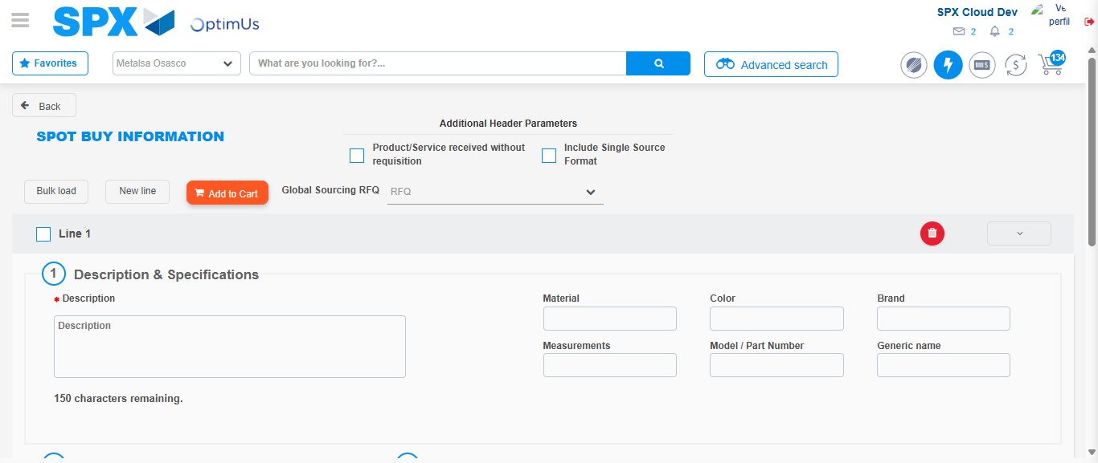Image file-name: QC_Testing-tc001_SPX_Dev5_Crear_Requisicion_Spot_Tipo_Cobro_CC-1788297532965

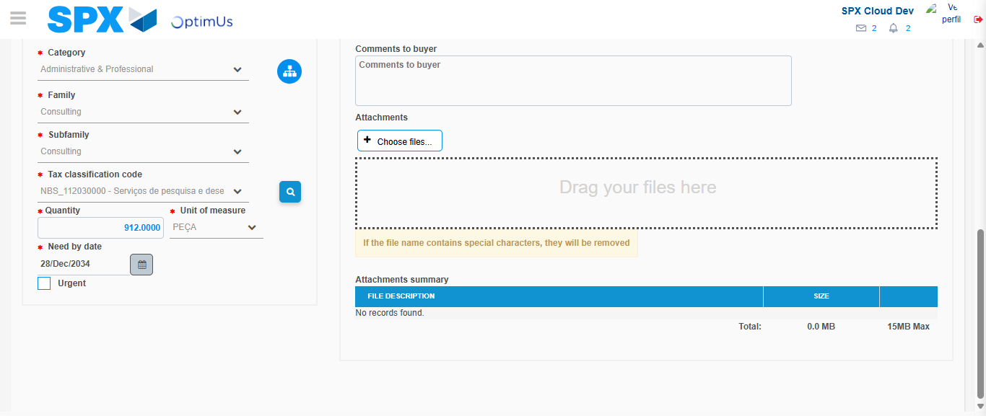Image file-name: QC_Testing-tc001_SPX_Dev5_Crear_Requisicion_Spot_Tipo_Cobro_CC-1788297548606

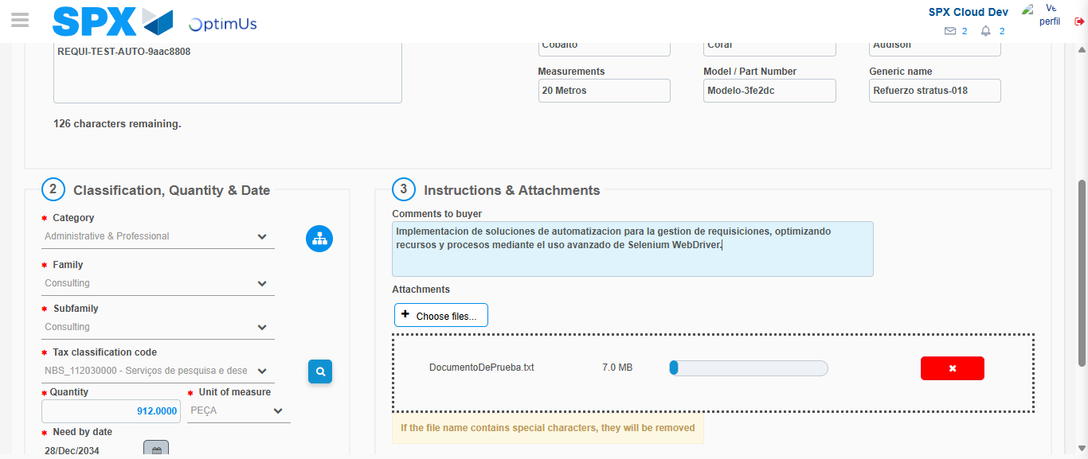Image file-name: QC_Testing-tc001_SPX_Dev5_Crear_Requisicion_Spot_Tipo_Cobro_CC-1788297549431

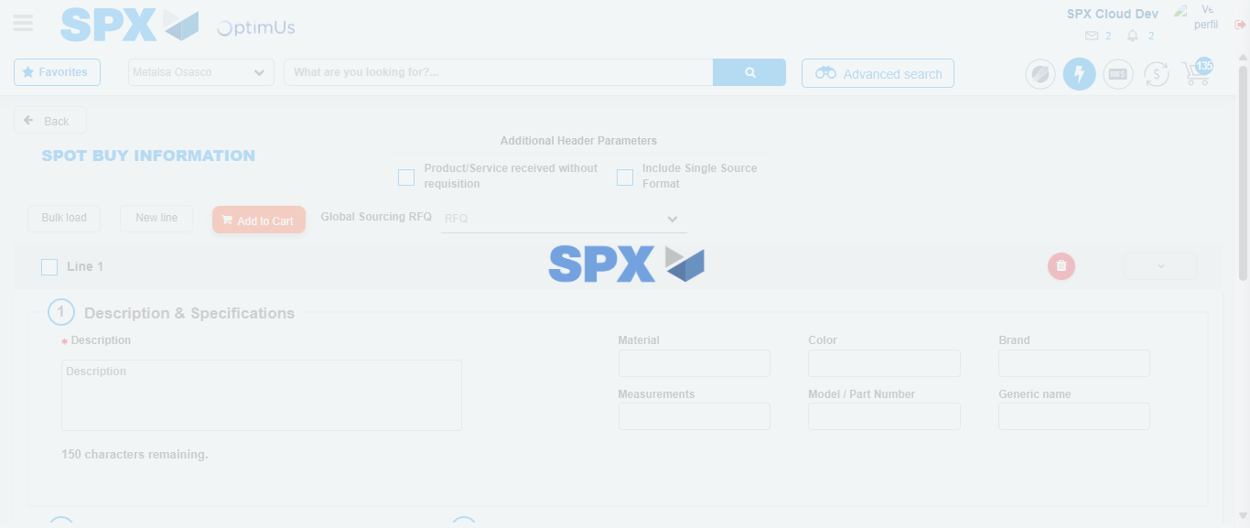Image file-name: QC_Testing-tc001_SPX_Dev5_Crear_Requisicion_Spot_Tipo_Cobro_CC-1788297553031

Step 7 - Return to Main Page SPX : Return to Main Page SPX
Image file-name: QC_Testing-tc001_SPX_Dev5_Crear_Requisicion_Spot_Tipo_Cobro_CC-1788297508564

Image file-name: QC_Testing-tc001_SPX_Dev5_Crear_Requisicion_Spot_Tipo_Cobro_CC-1788297509287

Image file-name: QC_Testing-tc001_SPX_Dev5_Crear_Requisicion_Spot_Tipo_Cobro_CC-1788297532605

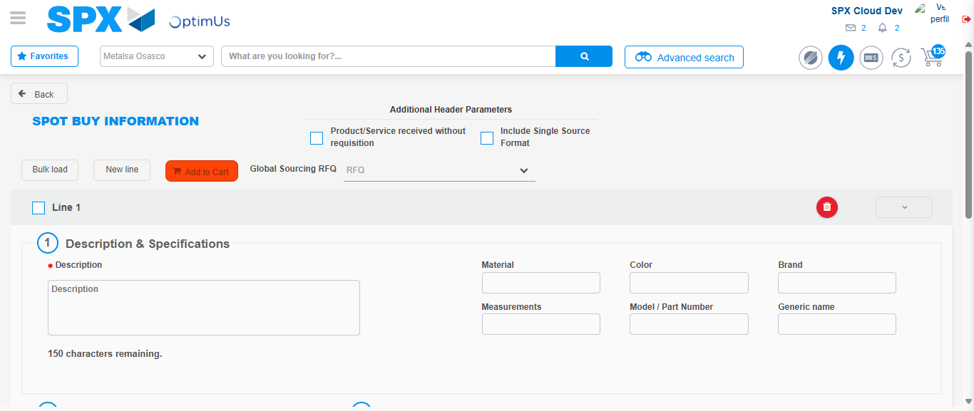Image file-name: QC_Testing-tc001_SPX_Dev5_Crear_Requisicion_Spot_Tipo_Cobro_CC-1788297555291

Image file-name: QC_Testing-tc001_SPX_Dev5_Crear_Requisicion_Spot_Tipo_Cobro_CC-1788297555477

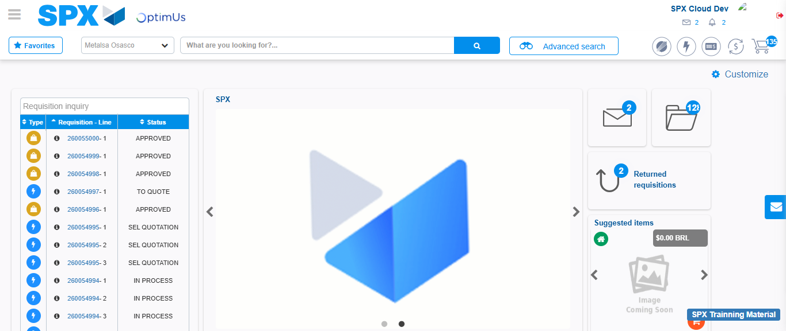Image file-name: QC_Testing-tc001_SPX_Dev5_Crear_Requisicion_Spot_Tipo_Cobro_CC-1788297576803

Step 8 - Log Out : Log Out SPX
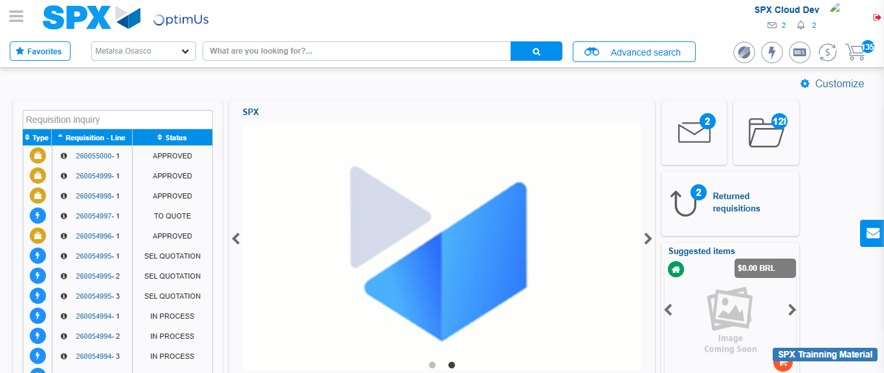Image file-name: QC_Testing-tc001_SPX_Dev5_Crear_Requisicion_Spot_Tipo_Cobro_CC-1788297577156

